The Missing Doll

Jane was very sad. She could not find her doll. Her mom said, “Look in your room. Maybe your doll is there.” Jane looked in her room. It was a terrible mess. She started to clean her room. She put all the books on the shelf. She put her blankets on her bed. She picked up her clothes off the floor.

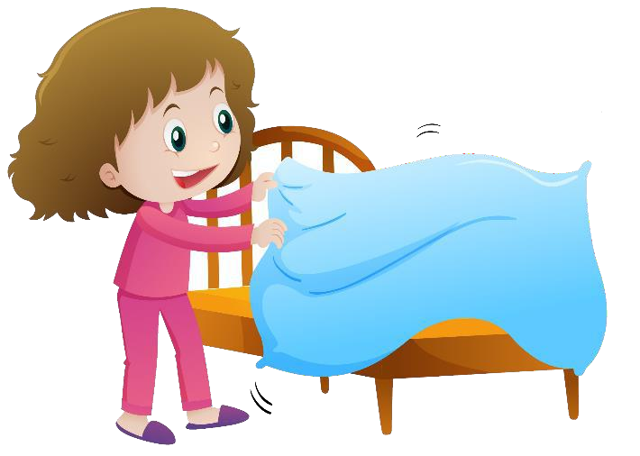

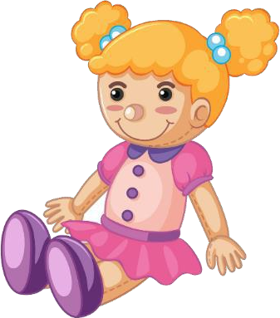“I found her,” Jane said. “My doll was hiding under my clothes. I think she was playing hide and seek.” Jane put her doll in the dollhouse. Her room was clean, and now it was time to play.